MicroGoals – Secure Goal Management Backend API

Team ID : SWTID-2026-8260

Team Leader:
Name: Asmirathi S
Email ID: 201400063@sigc.edu

Team Members:
1. Name: Bavana Sri S
Email ID: 202400881@sigc.edu

2.Name: Abirami G
Email ID: 202400311@sigc.edu

3.Name: Ellakiya
Email ID: 202400361@sigc.edu

Project Overview
MicroGoals is a secure backend RESTful API developed using Node.js, Express.js, and MongoDB. It enables users to register, log in, and manage their personal goals through CRUD operations. The system uses JWT authentication and middleware to ensure data security and user-specific access control.
The system includes:
- User Registration & Login

- JWT-based Authentication

- CRUD Operations for Goals

- Protected Routes

- Centralized Error Handling

The main objective is to provide a secure and scalable backend system for digital goal management.

Project Instruction
- The project follows REST API principles.

- Authentication is handled using JWT.

- MongoDB is used as the database.

- APIs are tested using Thunder Client.

- The project follows MVC architecture.

Pre-requisites
Before running the project, the following tools are required:
- Node.js (v18 or higher)
- Express.js
- MongoDB (Local / Atlas)
- VS Code
- Thunder Client (Extension)
- Basic knowledge of JavaScript & REST APIs

Project Architecture Image (Text Representation)
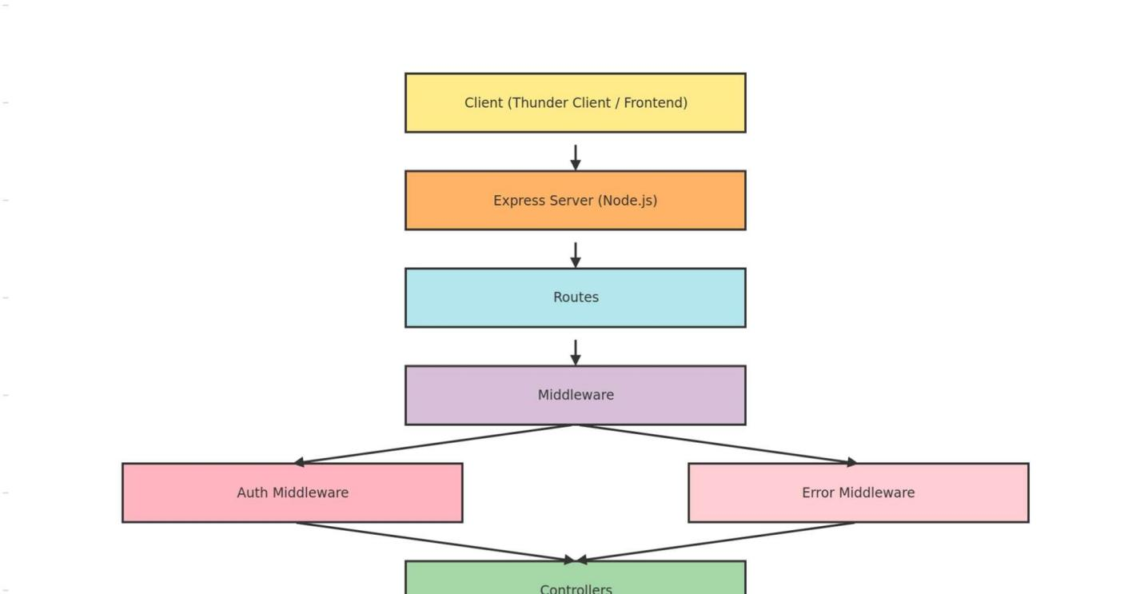

PROJECT ARCHITECTURE

TECHNICAL ARCHITECTURE
- Runtime: Node.js

- Framework: Express.js

- Database: MongoDB

- Authentication: JWT

- Architecture Pattern: MVC

ER DIAGRAM
Entities:
- User

  - _id

○ name

○ email

○ password

- Goal

  - _id

○ title

○ completed

○ userId (Reference to User)

Relationship:
One User → Many Goals
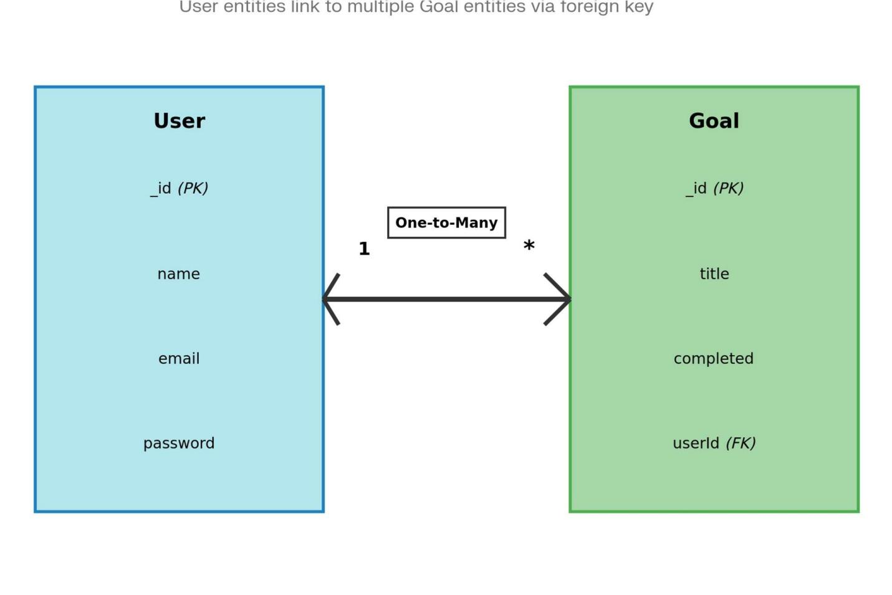

FEATURES
- User Registration

- Secure Login with JWT

- Create Goal

- Update Goal

- Delete Goal

- View User-specific Goals

- Protected Routes

- Centralized Error Handling

ROLES AND RESPONSIBILITIES
Role Responsibility
User Register, Login, Manage Goals
Developer API Development & Testing

USERS FLOW
- User registers

- User logs in

- JWT token generated

- User sends token in header

- Access protected routes

- Perform CRUD operations
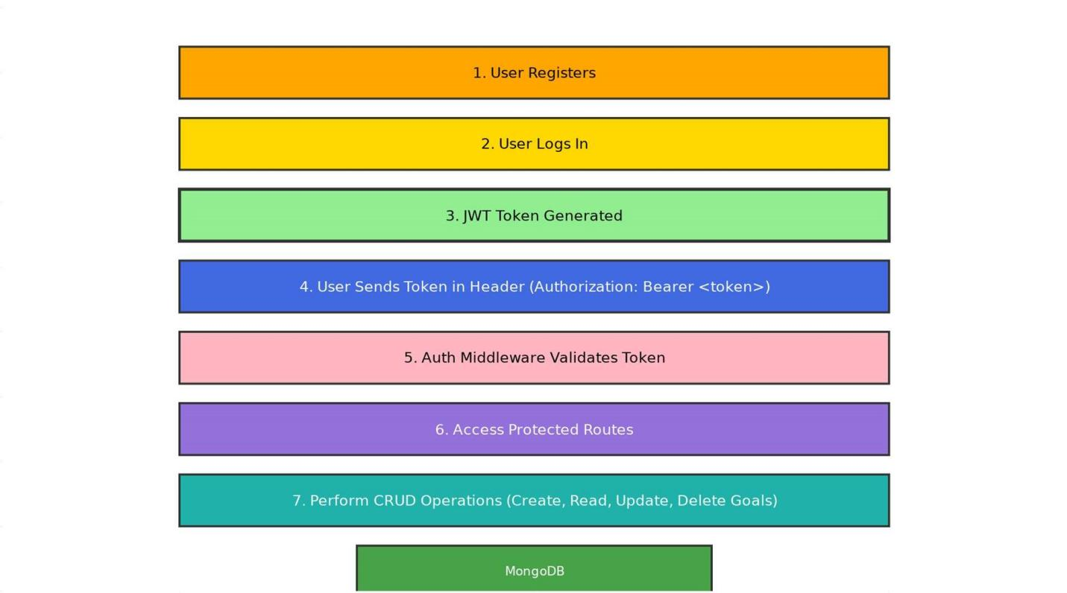

PROJECT SETUP AND CONFIGURATION

꾆 Folder Structure
MicroGoals/
├── middleware/
│ ├── authMiddleware.js
│ └── errorMiddleware.js
├──Schema/
├──User.js
├──GoalSchema.js
├── models/
│ ├── userModel.js
│ └── goalModel.js
│
├── routes/
│ ├── authRoutes.js
│ └── goalRoutes.js
│
├── .env
├── Index.js
└── package.json
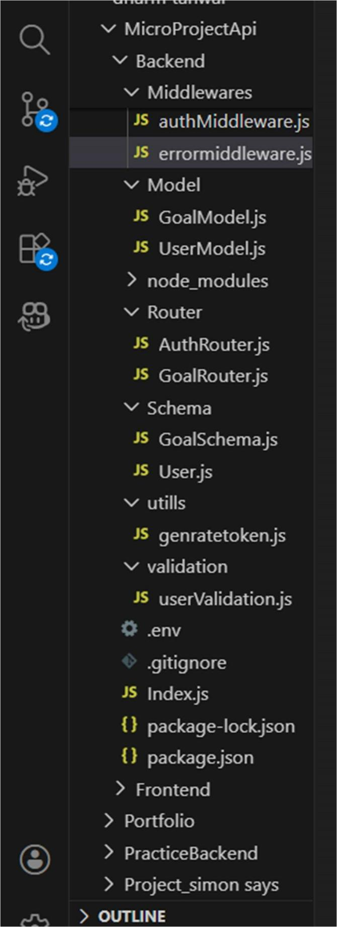

꾆 Project Setup
- npm init -y

- Install dependencies:

npm install express mongoose jsonwebtoken bcryptjs dotenv

- Start server:

node server.js

BACKEND DEVELOPMENT
- Created Express Server
An Express server was set up to handle API requests, connect routes, and enable JSON parsing for backend operations
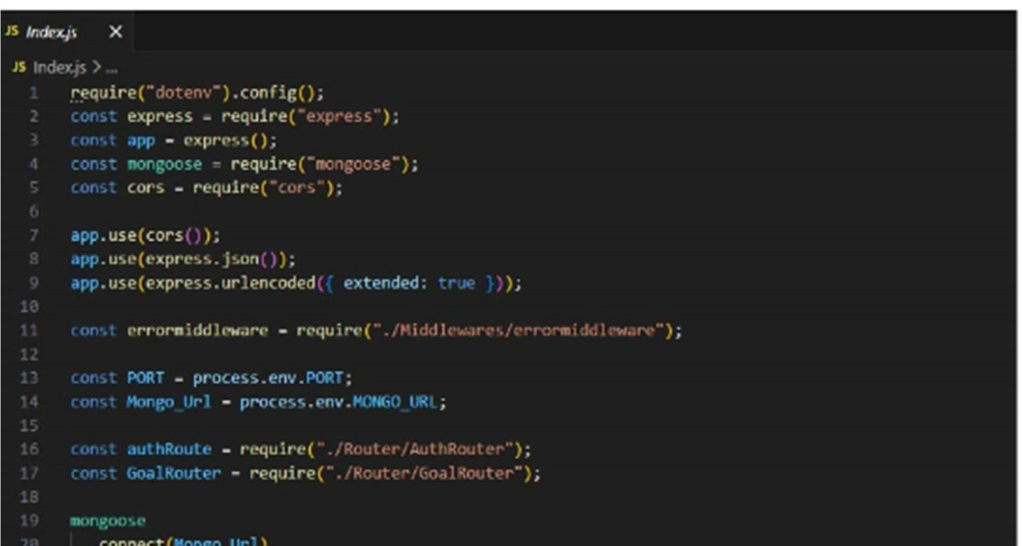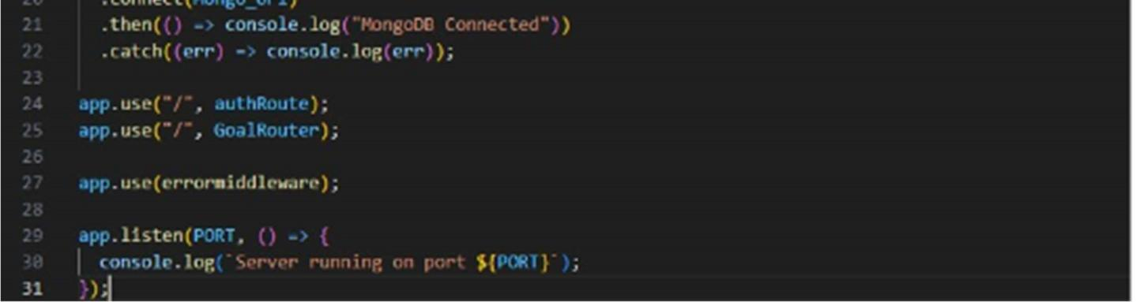
- Connected MongoDB
For Connection with MongoDB:-
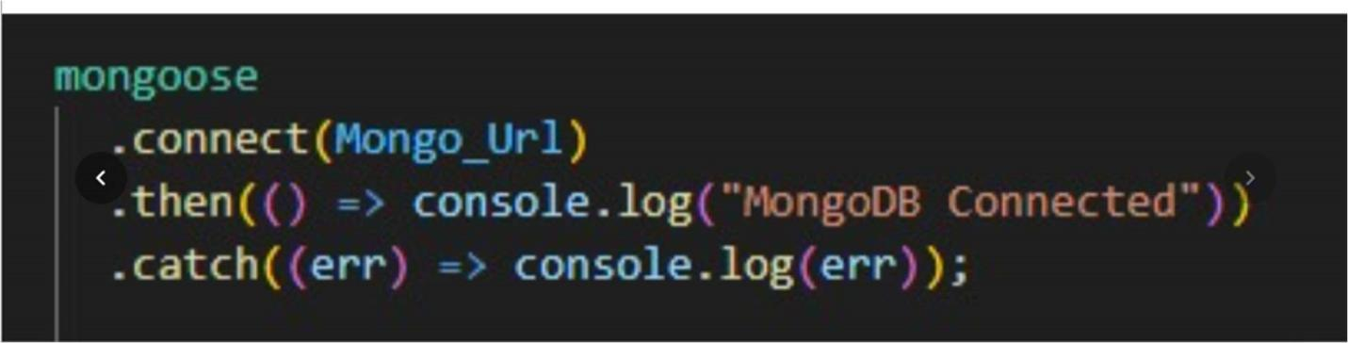

- Implemented Authentication API User registration and login APIs were created with password hashing and JWT token generation for secure authentication.
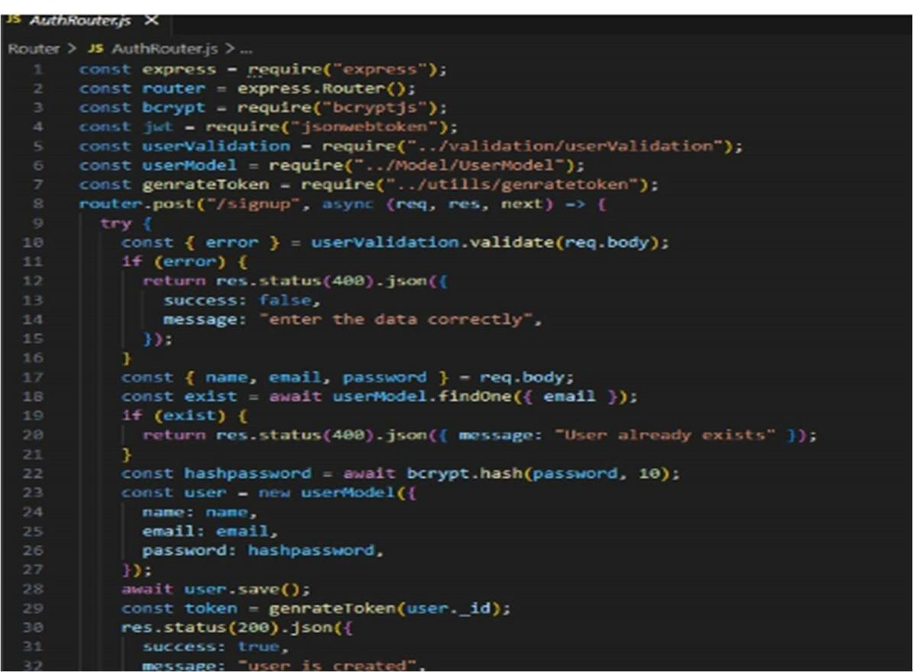
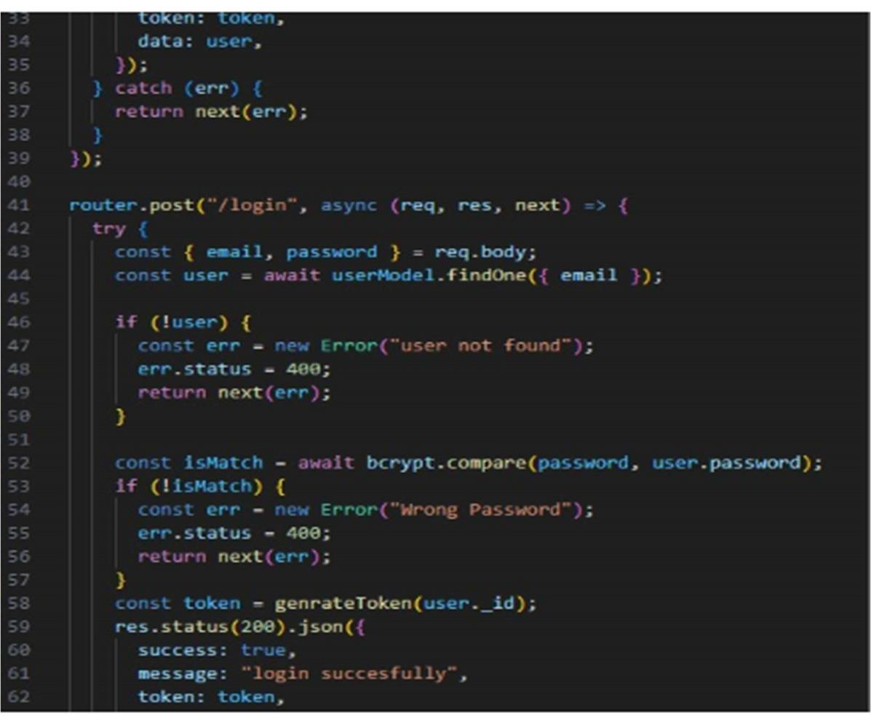
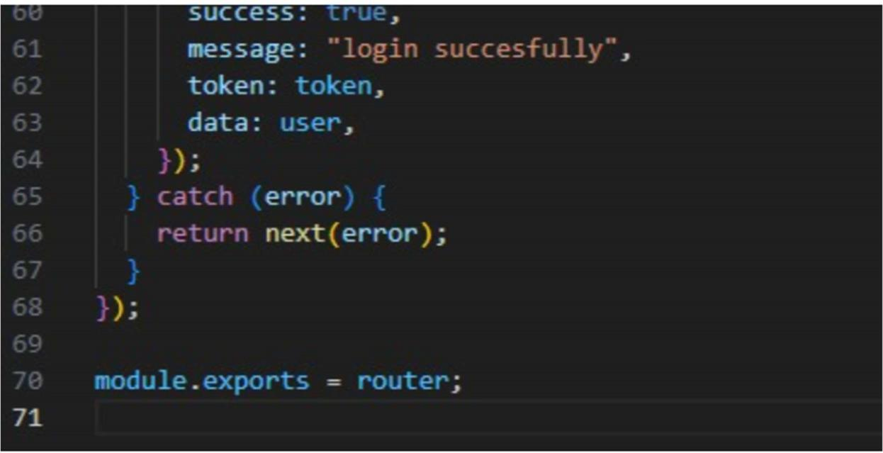
- Implemented Goal CRUD APIs
Goal CRUD APIs were implemented to allow authenticated users to perform full Create, Read, Update, and Delete operations on their personal goals. These APIs follow RESTful architecture principles and are designed to ensure secure and structured data management.
The Create API enables users to add new goals to the database. Each goal is associated with a specific user using a userId reference, ensuring user-specific data isolation.
The Read API allows authenticated users to retrieve only their own goals from the database. Data filtering is applied using the authenticated user's ID to prevent unauthorized data access.
The Update API enables users to modify existing goals. Proper validation checks ensure that only the owner of the goal can update it.
The Delete API allows users to permanently remove their goals from the system. Secure route protection ensures that users cannot delete goals belonging to others.
All CRUD routes are protected using Authentication Middleware, which verifies the JWT token before granting access. If the token is missing or invalid, the system returns a 401 Unauthorized error.
Additionally, Error Middleware is implemented to handle runtime and validation errors centrally. It captures exceptions from CRUD operations and returns consistent JSON responses with appropriate HTTP status codes such as 200, 201, 400, 401, and 404.
This structured implementation ensures secure data handling, proper authorization, and reliable API behavior across all goal management operations.

const express = require("express"); const router = express.Router(); const goalModel = require("../Model/GoalModel"); const authmiddleware = require("../Middlewares/authMiddleware");

router.post("/create", authmiddleware, async (req, res, next) => {
try { const { title } = req.body; const goal = new goalModel({
title: title, user: req.user,
}); await goal.save(); res.status(200).json({ success: true, data: goal,
});
} catch (err) { return next(err);
}
});

router.get("/:id", authmiddleware, async (req, res, next) => { try { const id = req.params.id; const data = await goalModel.findOne({
_id: id, user: req.user,
}); res.status(200).json({ success: true, data: data,
});
} catch (error) { return next(error);
}
});

router.put("/:id", authmiddleware, async (req, res, next) => { try {
const goal = await goalModel.findOneAndUpdate(
{ _id: req.params.id, user: req.user },
{ completed: req.body.completed },
{ new: true },
);
res.status(200).json({ success: true, message: "the goal is completed",
});
} catch (error) { return next(error);
}
});

router.delete("/:id", authmiddleware, async (req, res, next) => { try {
await goalModel.findOneAndDelete({
_id: req.params.id,
});

res.status(200).json({ message: "Goal deleted" });
} catch (error) { next(error);
}
});

module.exports = router;

- Added Auth Middleware
- Auth middleware was implemented to verify JWT tokens and secure protected routes from unauthorized access.
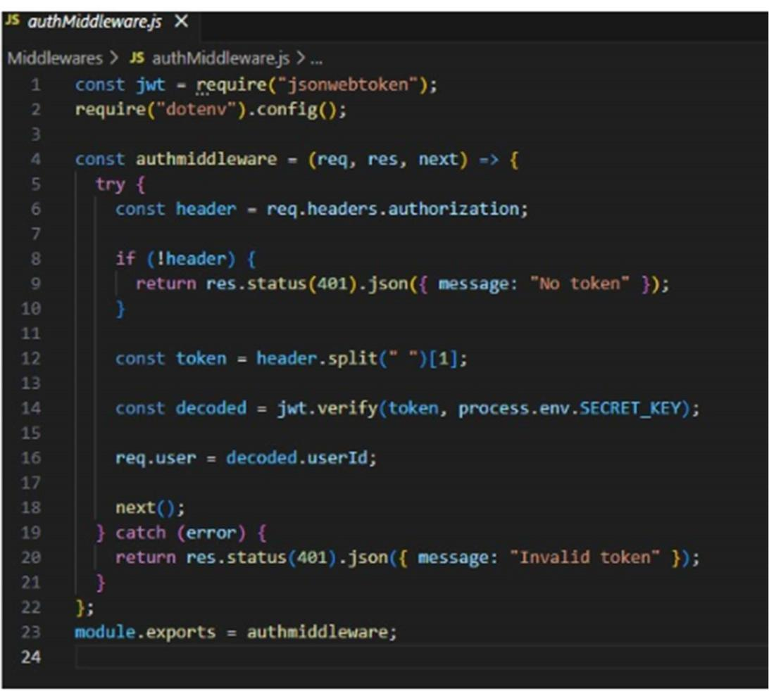
- Added Error Middleware
An error middleware was added to handle application errors centrally and return proper status codes and messages.
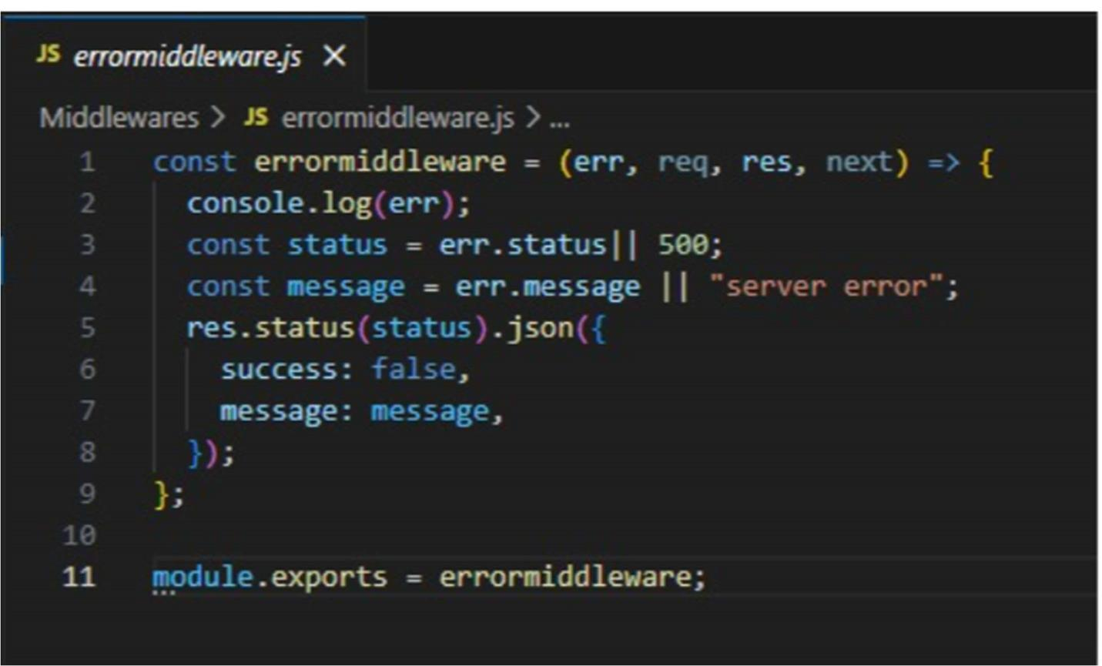

DATABASE DEVELOPMENT

CONFIGURE MongoDB
- Use MongoDB Atlas or Local MongoDB

- Store connection string in .env

CREATE DATABASE CONNECTION
Index.js file:
- Use mongoose.connect()
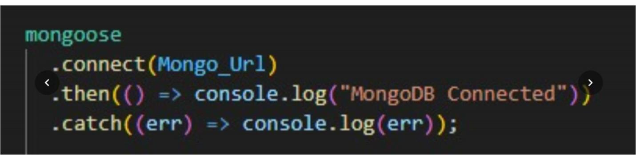

- Handle connection errors

CREATE SCHEMA AND MODELS
User Schema
The User Schema defines the user data structure with name, email (unique), and hashed password fields.
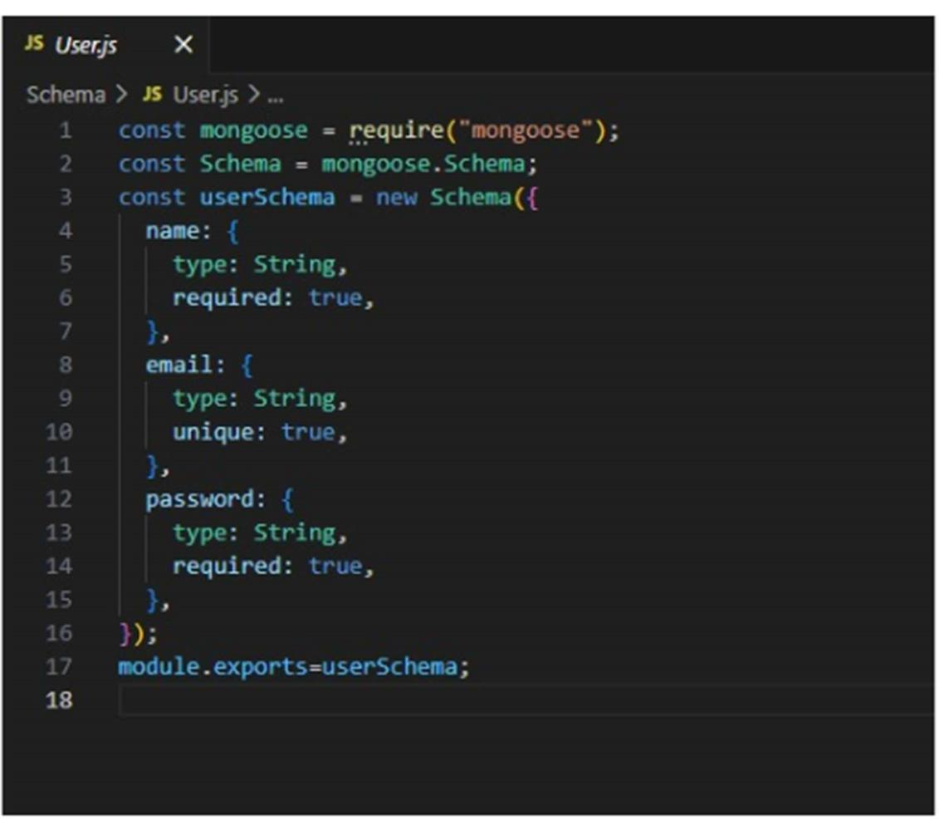

Goal Schema (with userId reference)
The Goal Schema stores goal details and includes a userId reference to associate each goal with a specific user.

PROJECT EXECUTION

Project Execution Steps
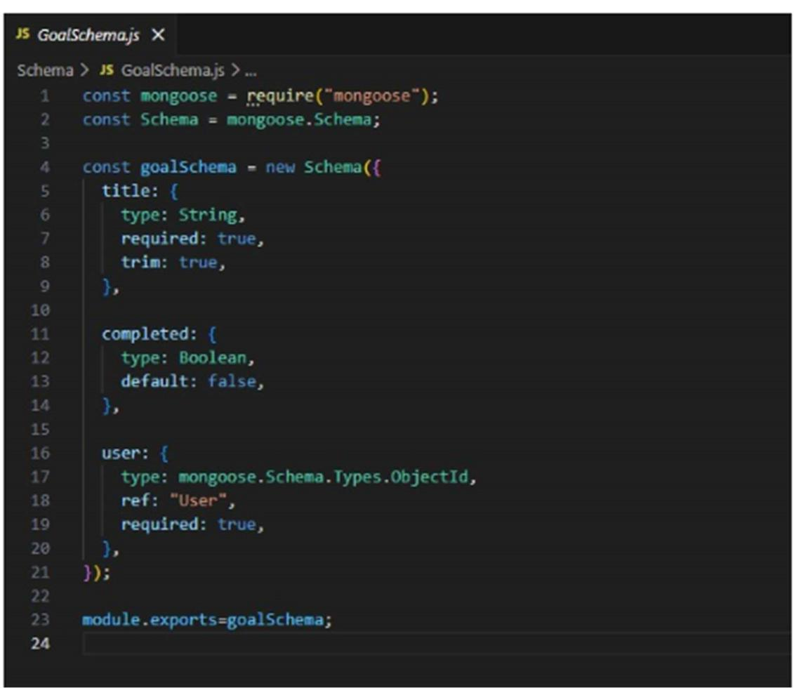
Start MongoDB

- Run server

- Test APIs in Thunder Client

- Register User

- Login and get JWT

- Perform CRUD operations

Project Output Screenshots
- Successful User Registration(Signup/Login)
- In this Api call the user register or login and token was genrated
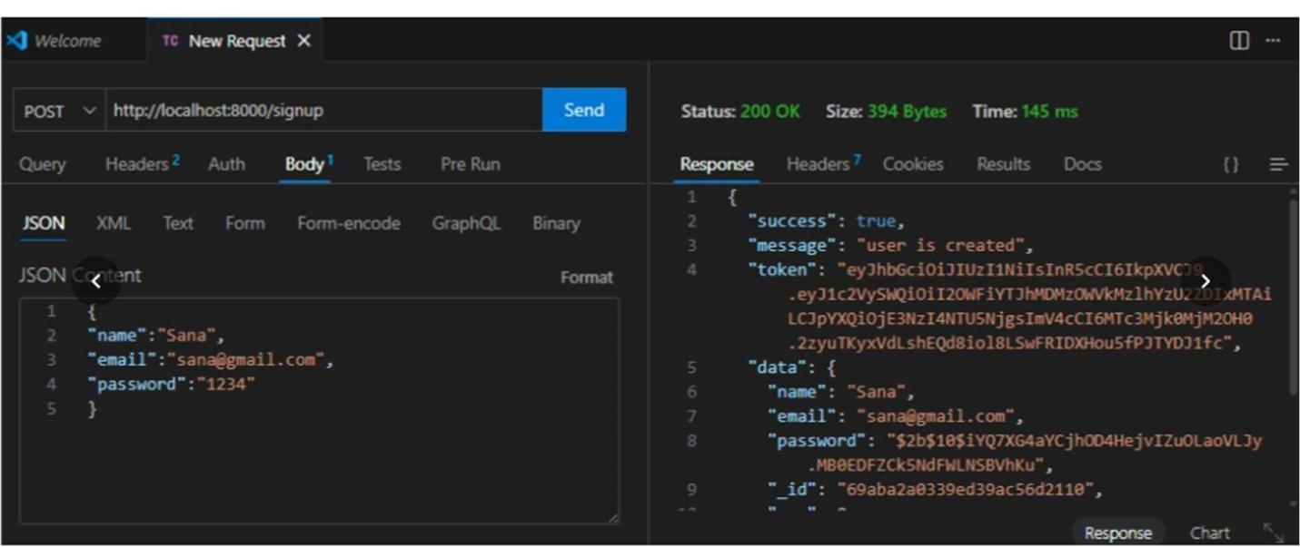

- JWT Token Response
After successful login user the api generate the token and these token was sent with every request to every api
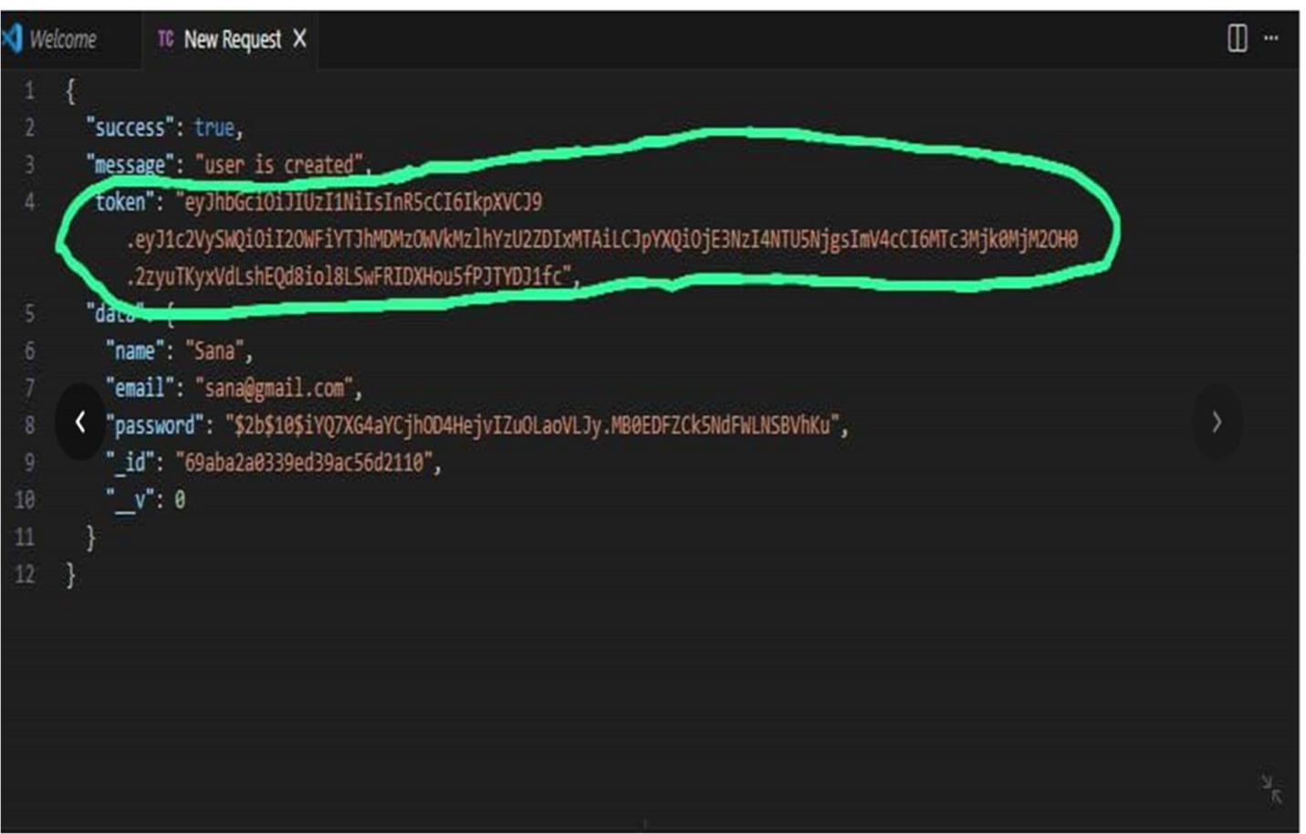

- Goal Created Successfully
- After the login and token is generated the user give post request to api for creating there goals and goal was save in MongoDB which was the database

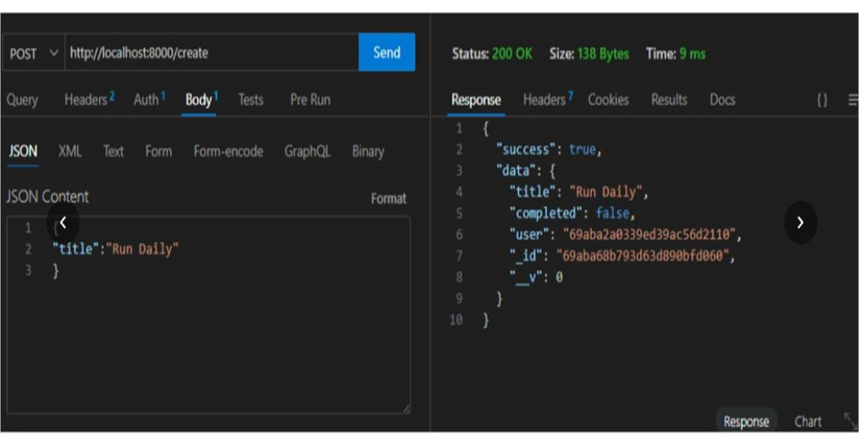

- Protected Route Working
- If the user does not have token which was generated by backend api then he cannot access the api so Route are protected
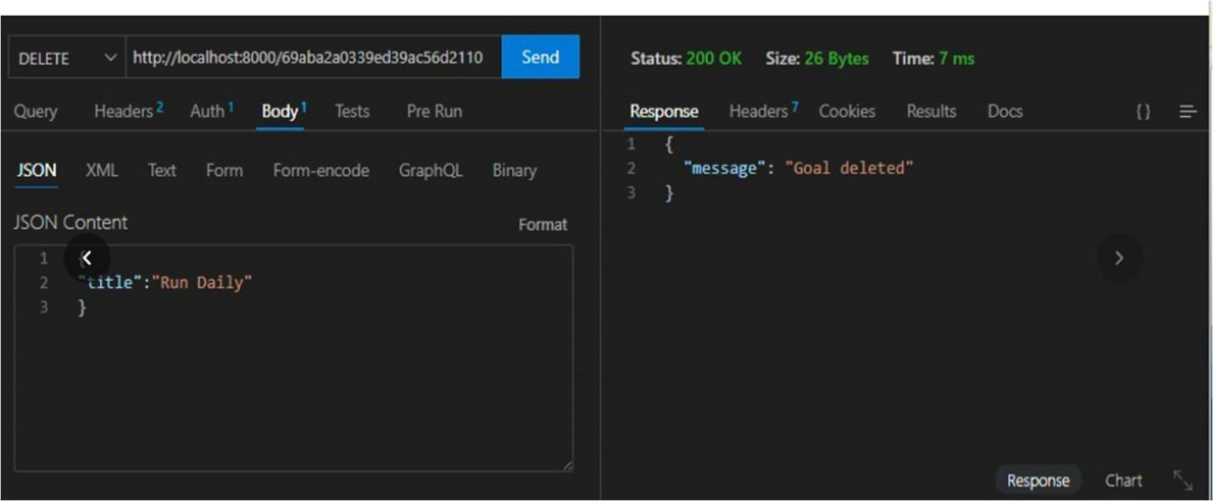

Project Demo Video
Record video showing:
- Registration

- Login

- Token usage

- CRUD operations

- Error handling video:Microgoal video
Drive:-MicroGoal(Backend)

